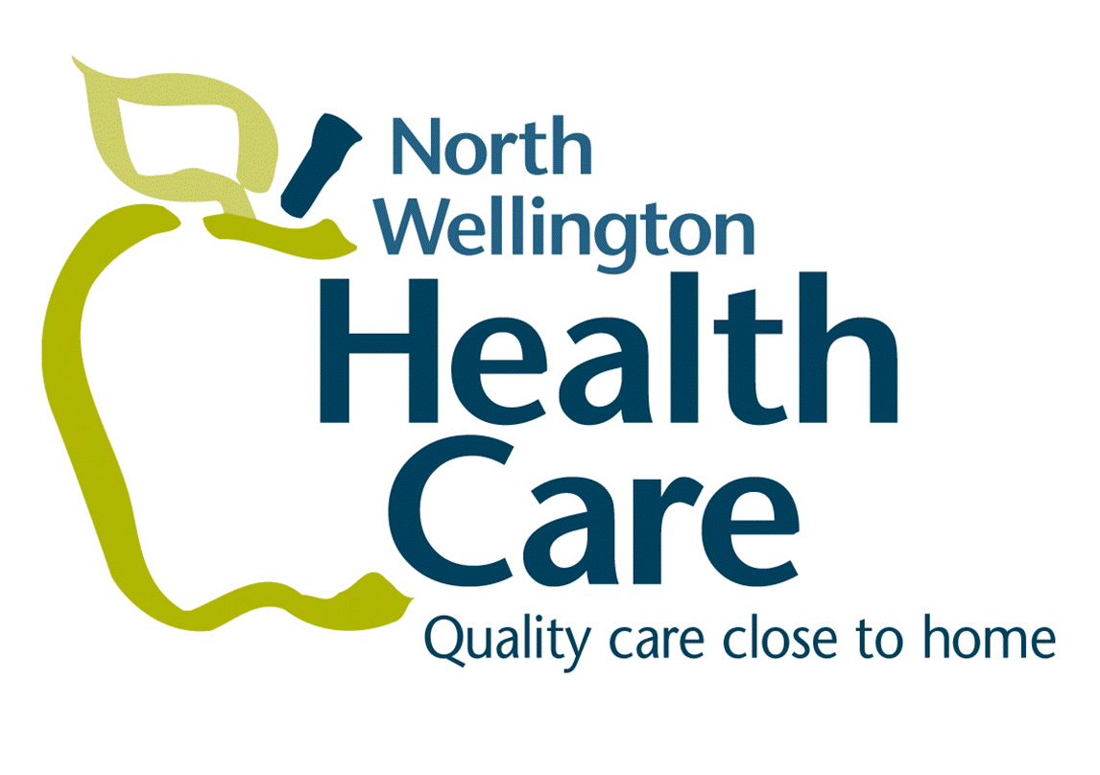
December 5, 2017
Media Release
For Immediate Release
Palmerston, ON…North Wellington Health Care (NWHC) has successfully achieved designation from the Breastfeeding Committee for Canada under the World Health Organization and UNICEF Baby-Friendly Initiative. NWHC is the fifth hospital in Ontario and the first Level One perinatal hospital* to attain the BFI designation. (*Level One perinatal hospitals provide care to uncomplicated, low-risk pregnant women and newborns.)
The Baby-Friendly Initiative is a global program launched by the World Health Organization (WHO) and UNICEF. Official designation involves successful compliance with criteria outlined in the Ten Steps to Successful Breastfeeding as established and defined by the WHO and UNICEF as well as Practice Outcome Indicators for Hospitals as set out by the Breastfeeding Committee for Canada. The hospital initiative is aimed at ensuring all levels of the organization promote and support a baby-friendly environment, with an emphasis on the importance of breastfeeding for infant health.
“NWHC’s staff and physicians, at both Louise Marshall Hospital and Palmerston & District Hospital, worked incredibly hard to achieve this designation.” states Stephen Street, NWHC President and CEO. “They have created a culture that protects, promotes, and supports breastfeeding, which evidence indicates will lead to healthier children, and in the long run, healthier communities.”
“Work to achieve BFI designation has been a four-year process, with all staff, physicians and midwives participating.” explains Nancy Cleary, NWHC Patient Care Manager and BFI Lead. “This work reflects North Wellington’s desire to provide mothers and infants with the best of care.”
Some of the work to achieve BFI designation included:
- Placing babies directly skin to skin with their mother following birth
- Supporting rooming-in, so babies remain with mother following birth
- Continual best practice breastfeeding education for Nurses
- Parental support to make informed decisions
- Development of parent information materials
- Ongoing surveillance of breastfeeding rates
- Adherence to the WHO Code for Marketing of Breastmilk Substitutes – NWHC does not accept any financial support from companies which produce artificial feedings or pacifiers nor allow formula companies to advertise or distribute free samples through our hospitals
MORE…/2
-2-

“The BFI designation supports North Wellington Health Care’s mission: by working together we are able to advance exceptional care and wellness for our patients and their families.” states Street.
-30-

Media Contact:
Alison Armstrong
226.820.1798

